Task 11 – Storage Options Report
Item | Detail
Student | Kabir Singh Thukrai (99281336)
Industry Supervisor | Abdul Rehman
Project | Kubernetes Observability Lab for DSYS601 (BCIS309)
Date tested | 29 September 2026 (report updated 5 October 2026)
Status | For supervisor review. Nothing has been changed yet.

empty Dir is enough for the lab. Persistent Volumes are not needed.
I recommend two small changes. First, add an emptyDir volume to Redis, because right now Redis has no volume at all and loses its data every time its container restarts. Second, have the demo API write something to Redis, because at the moment it stores nothing there.
What each storage type does
Storage type | What it is
No volume | Data is saved inside the container itself.
emptyDir | A temporary folder that lives as long as the pod lives.
PersistentVolume (PVC) | In Kind, a folder on one node’s disk that stays after the pod is deleted.

What the lab uses today
Component | Storage | What gets lost if the pod is replaced
Prometheus | emptyDir | Old metrics history
Alertmanager | emptyDir | Alert silences
Grafana | emptyDir | Nothing important. Dashboards are saved as ConfigMaps and reload by themselves.
Redis (demo app) | No volume | All data, even on a simple container restart

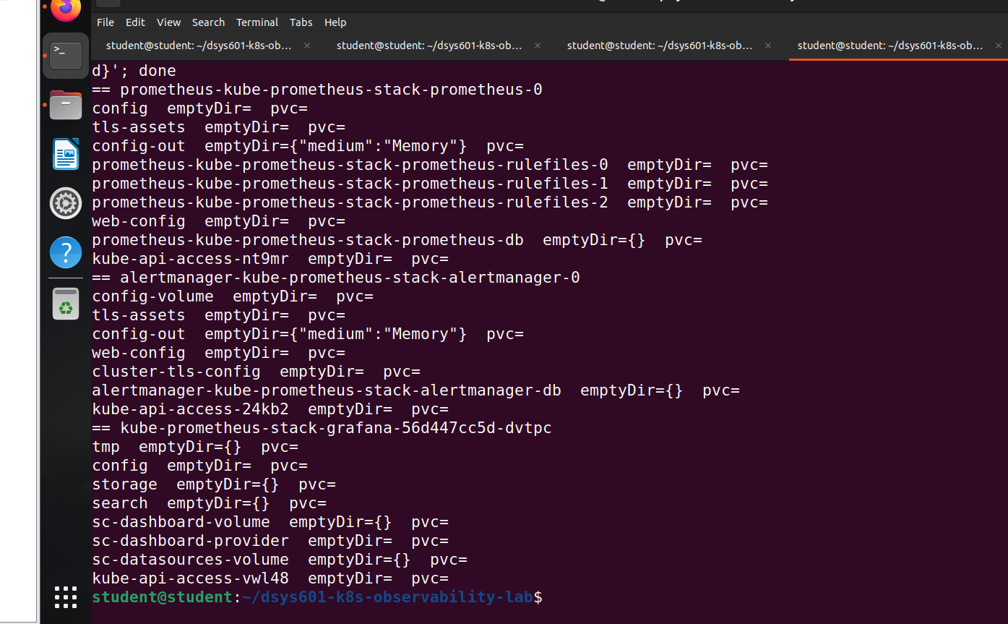
Figure 1: Prometheus, Alertmanager and Grafana all use emptyDir.
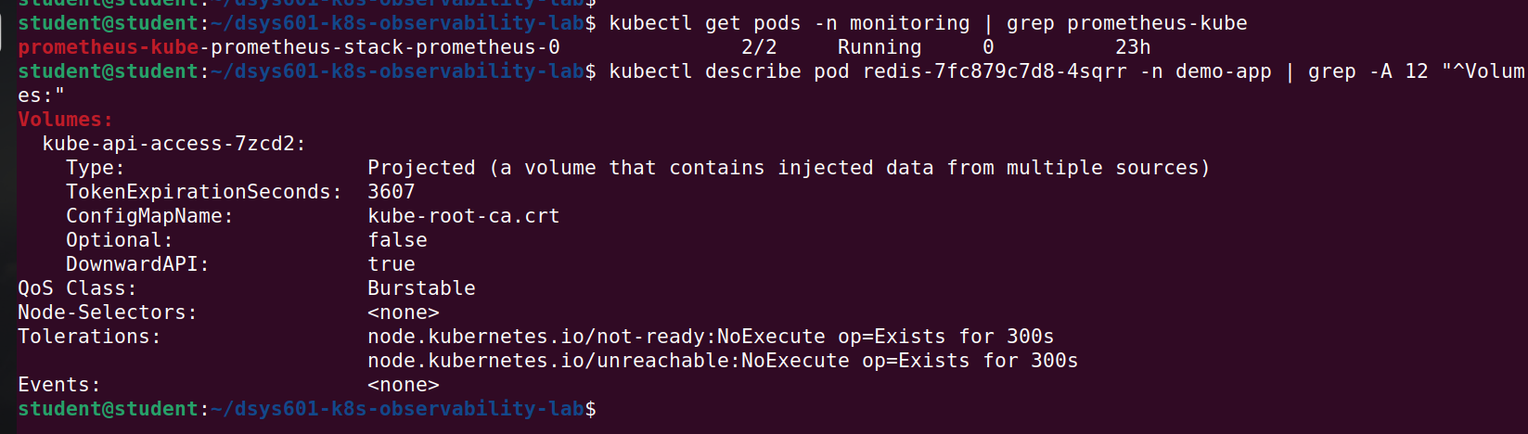
Figure 2: Redis has no data volume.
What I tested
I ran tests 1–4 and 6 in a separate test namespace so the real lab was not affected. Test 5 deletes the whole cluster, so I ran it on a separate demo cluster instead.
# | Test | Result
1 | Restart the container 3 times (emptyDir) | Data kept
2 | Delete the pod and recreate it (emptyDir) | Data lost
3 | Delete the pod and recreate it (PVC) | Data kept
4 | Cordon the PVC’s node (worker2) and delete the pod | Pod stuck in Pending – it could not move to the other worker
5 | Delete and rebuild the whole cluster (PVC, separate demo cluster) | Data lost
6 | Restart the Redis container | Data lost

Test 1 and 2 – emptyDir
emptyDir kept the file through 3 container restarts, including CrashLoopBackOff. When the pod was deleted, the file was gone, even though the new pod landed on the same node. emptyDir is removed when its pod is removed (The Kubernetes Authors, 2026c).
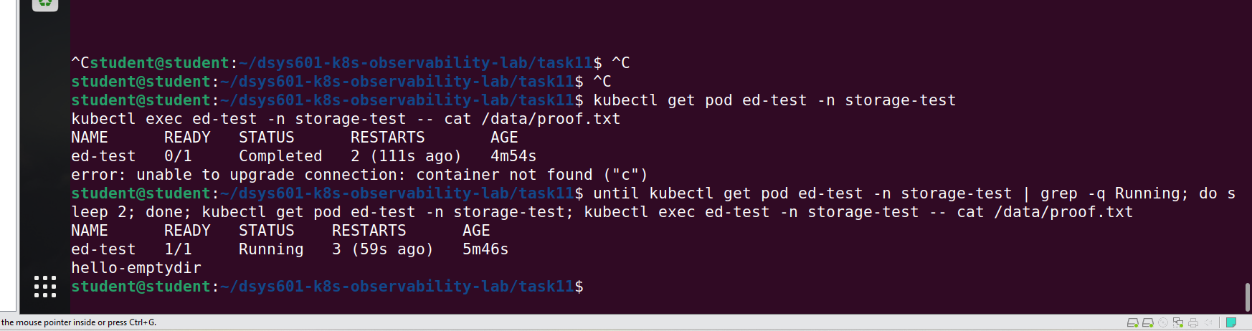
Figure 3: After 3 restarts, the file is still there.
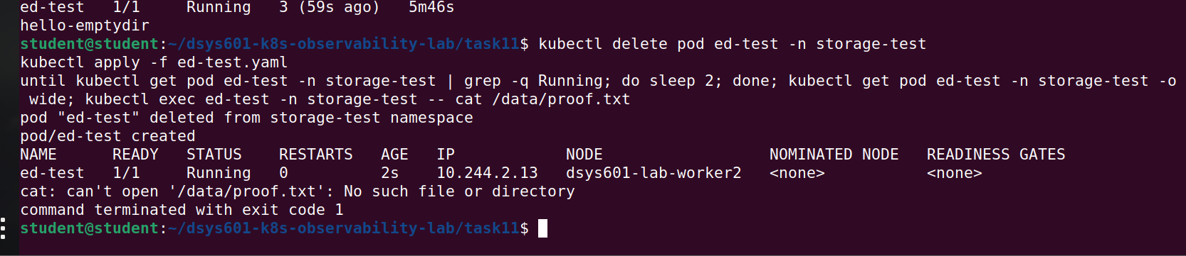
Figure 4: After the pod was deleted, the file is gone.
Test 3 and 4 – PersistentVolume
The PVC kept its data when the pod was deleted, because a PersistentVolume exists separately from the pod (The Kubernetes Authors, 2026b). But the data only lives on one node (worker2), because Kind’s default storage (local-path-provisioner) keeps PV data in a folder on that node (Rancher, n.d.). I then cordoned worker2, which marks it as unschedulable (The Kubernetes Authors, 2026a), and deleted the pod. The new pod could not start on the other worker and stayed in Pending until I uncordoned worker2. A cordon is not a node failure, but a real node failure would leave the pod stuck in the same way, because the data is only on that node.
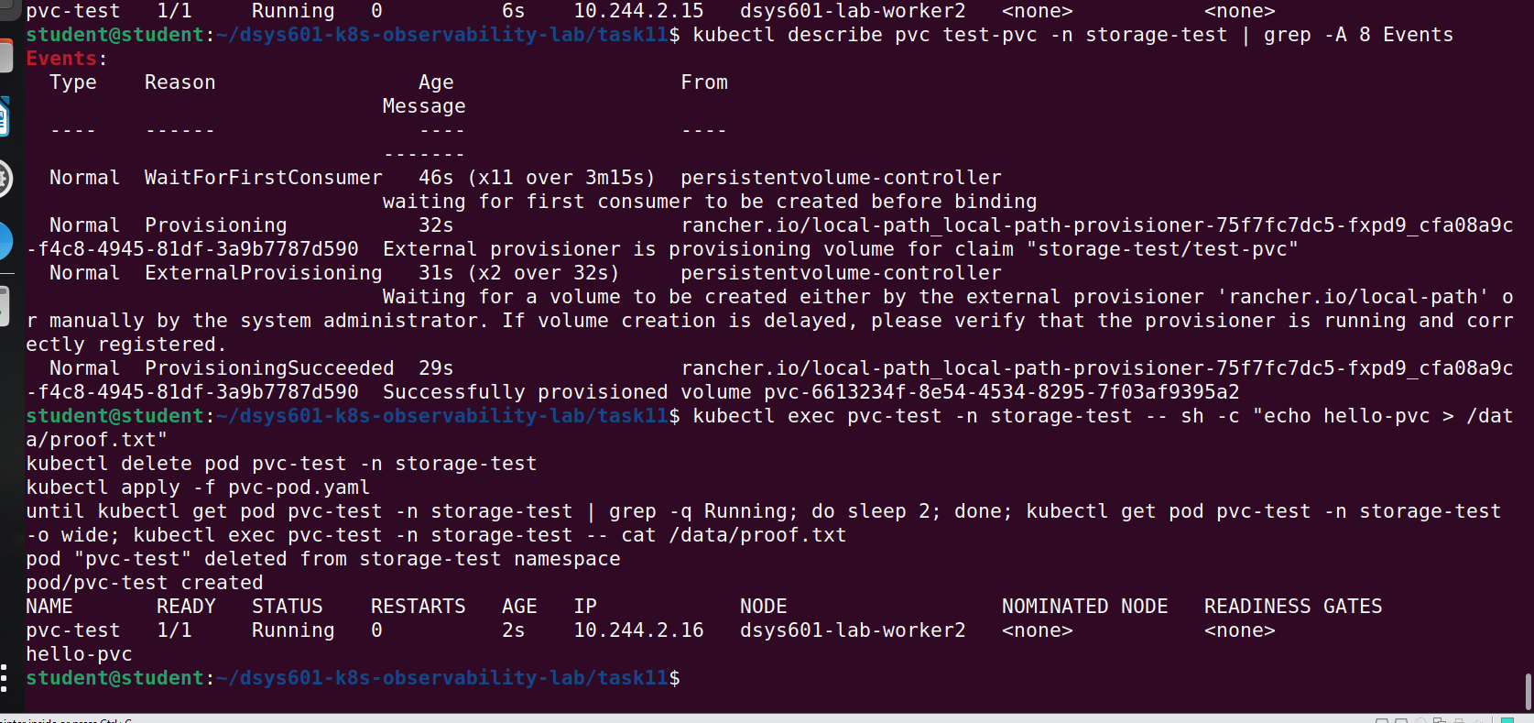
Figure 5: Pod deleted and recreated: the PVC data survived.
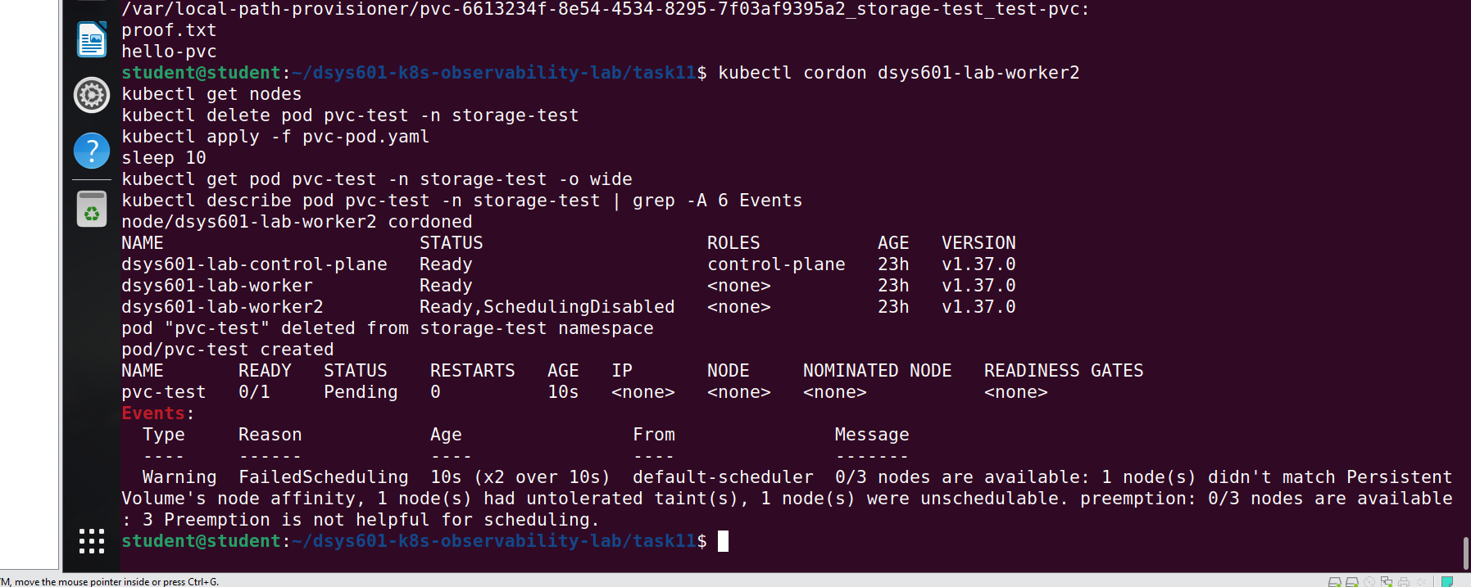
Figure 6: With worker2 cordoned, the pod cannot start anywhere else.
Test 5 – cluster rebuild
I ran this test on a separate demo cluster, not the lab cluster. After deleting and recreating the cluster, no PVCs or data were left. This means every storage type is wiped when the cluster is rebuilt for a new cohort.
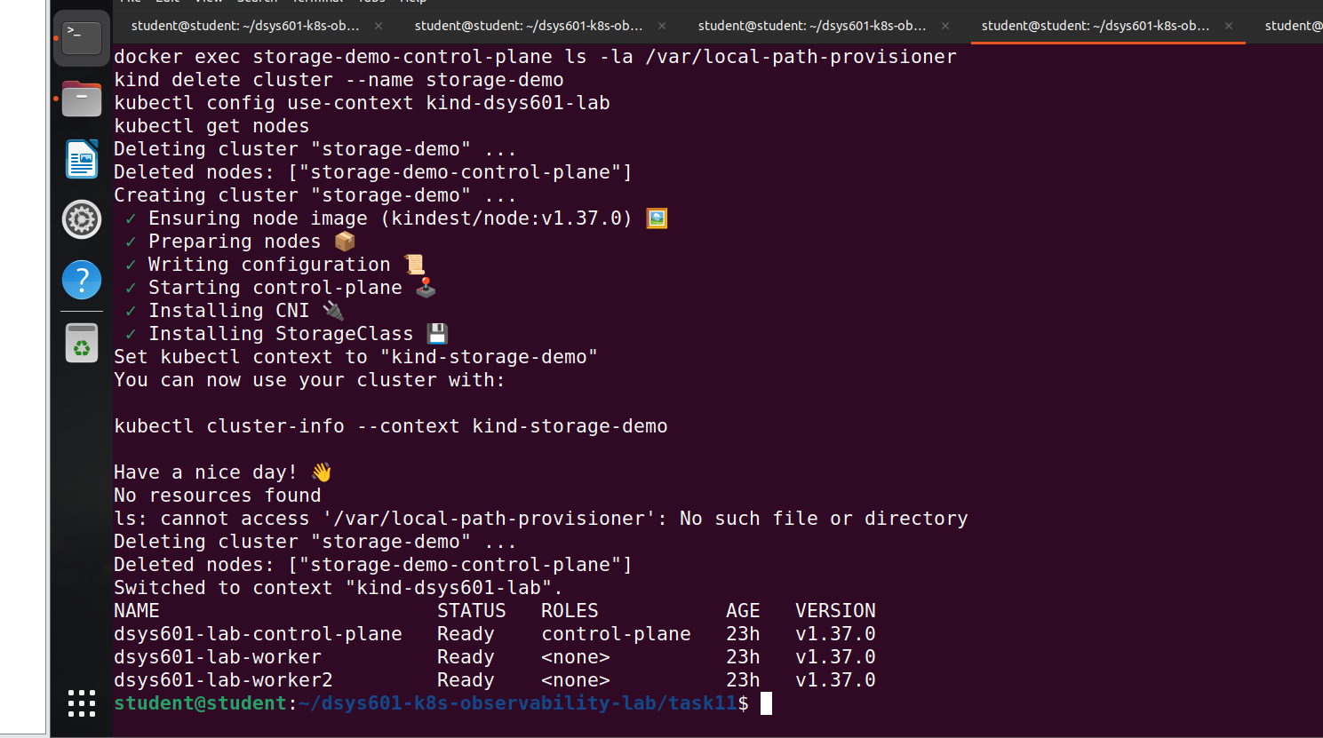
Figure 7: After the rebuild: no PVC, no PV, no data.
Option I considered – Kind extraMounts
Kind can mount a folder from the VM into a node using extraMounts (The Kubernetes Authors, 2025). If the folder where Kind stores PV data is mounted this way, the files stay on the VM after the cluster is deleted (The Kubernetes Authors, 2025; Rancher, n.d.). I did not recommend it for the lab because it ties the data to one VM, it carries old data into the next cohort when each cohort should start clean, it needs extra setup to reconnect the old data to a new PVC, and the data is still on one node.
Test 6 – Redis
I saved a test key in Redis and restarted its container. The key was gone afterwards. Redis tries to save to disk, but without a volume that save is lost with the container (Redis, 2026). Redis held 0 keys before the test, because the demo API does not write anything to Redis yet. So the demo app lost nothing, but it also means the labs cannot show data being lost or kept. I recommend changing the API to write a visit counter to Redis (see Recommendation).
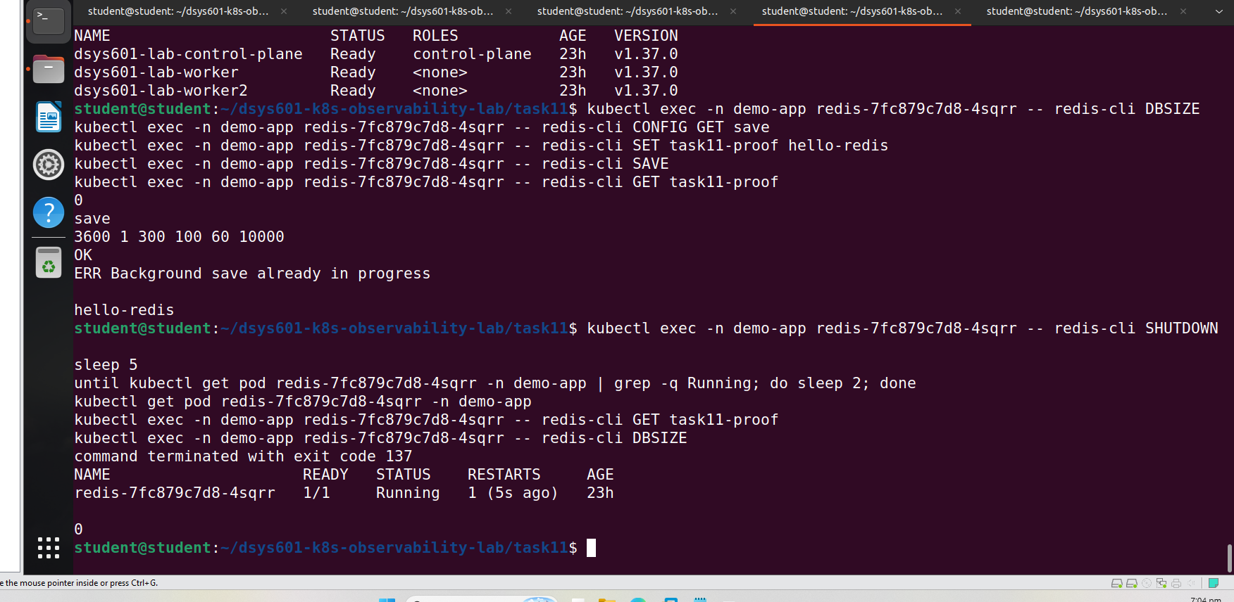
Figure 8: The Redis key is lost after one container restart.
Summary
Storage type | Container restart | Pod deleted | Node cordoned, pod moved | Cluster rebuilt
No volume (Redis now) | Lost | Lost | Lost | Lost
emptyDir | Kept | Lost | Lost | Lost
PVC | Kept | Kept | Pod stuck | Lost

Because everything is wiped on rebuild anyway (unless extraMounts is used), a PVC only helps during one cohort, and it adds the risk of pods getting stuck on one node.
Recommendation
Component | Recommendation
Redis | Add an emptyDir volume at /data. Test again afterwards to confirm it works.
Demo API | Write a visit counter to Redis on each request, so the labs can show data being lost (no volume) or kept (emptyDir).
Prometheus | Keep emptyDir. Use a short data retention period.
Alertmanager | Keep emptyDir.
Grafana | Keep as it is. Always save dashboards as ConfigMaps in Git.
Teaching | Add an optional lab about PersistentVolumes using these tests.

Decisions for the supervisor
# | Decision | My recommendation | Approved (Y/N)
1 | Storage for Redis | emptyDir
2 | Storage for the monitoring stack | Keep emptyDir
3 | Add an optional PersistentVolume lab | Yes
4 | Make the demo API write to Redis | Yes

Industry Supervisor: ______________________________ Date: _______________
References
The Kubernetes Authors. (2025, September 17). Configuration. kind. Retrieved October 4, 2026, from https://kind.sigs.k8s.io/docs/user/configuration/
The Kubernetes Authors. (2026a, August 26). kubectl cordon. Kubernetes. Retrieved October 4, 2026, from https://kubernetes.io/docs/reference/kubectl/generated/kubectl_cordon/
The Kubernetes Authors. (2026b, June 17). Persistent volumes. Kubernetes. Retrieved October 4, 2026, from https://kubernetes.io/docs/concepts/storage/persistent-volumes/
The Kubernetes Authors. (2026c, September 24). Volumes. Kubernetes. Retrieved October 4, 2026, from https://kubernetes.io/docs/concepts/storage/volumes/
Rancher. (n.d.). local-path-provisioner [Computer software]. GitHub. https://github.com/rancher/local-path-provisioner
Redis. (2026, September 30). Redis persistence. Retrieved October 4, 2026, from https://redis.io/docs/latest/operate/oss_and_stack/management/persistence/

